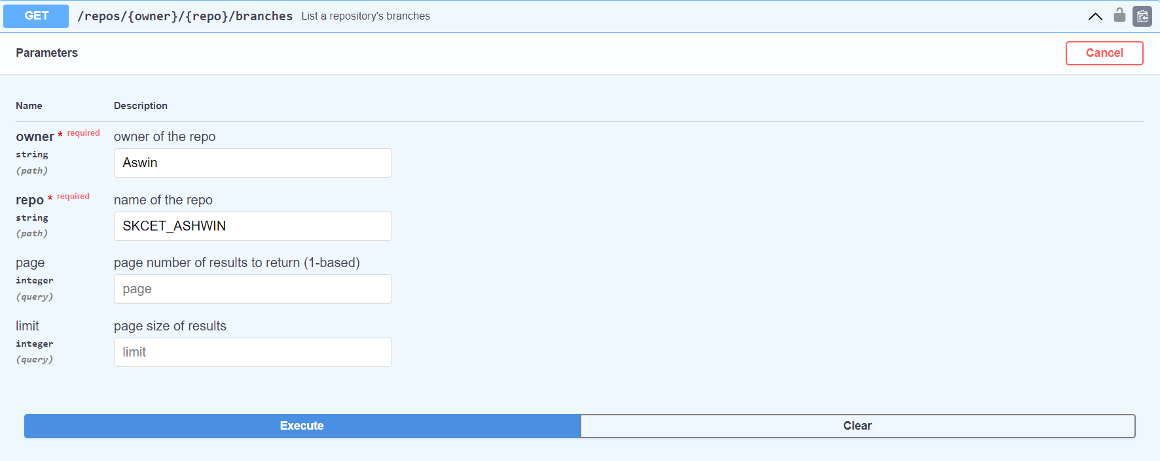

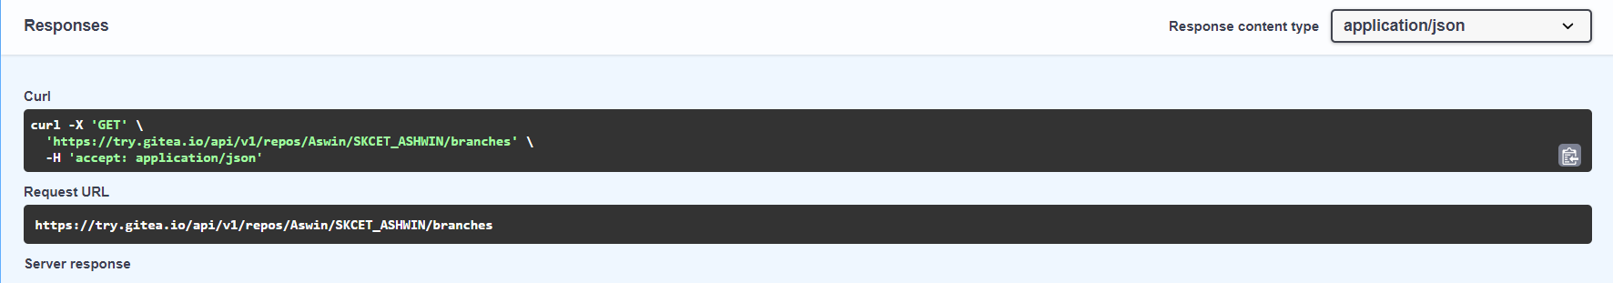

**Response body**

**Download**

**[**

**{**

**"name": "first",**

**"commit": {**

**"id": "64b8fbec1ffd722cd463d5885b242963a0fd4c26",**

**"message": "Initial commit\n",**

**"url": "https://try.gitea.io/Aswin/SKCET_ASHWIN/commit/64b8fbec1ffd722cd463d5885b242963a0fd4c26",**

**"author": {**

**"name": "Aswin",**

**"email": "aswin@noreply.try.gitea.io",**

**"username": "Aswin"**

**},**

**"committer": {**

**"name": "Aswin",**

**"email": "aswin@noreply.try.gitea.io",**

**"username": "Aswin"**

**},**

**"verification": {**

**"verified": false,**

**"reason": "gpg.error.not_signed_commit",**

**"signature": "",**

**"signer": null,**

**"payload": ""**

**},**

**"timestamp": "2023-02-21T06:17:45Z",**

**"added": null,**

**"removed": null,**

**"modified": null**

**},**

**"protected": false,**

**"required_approvals": 0,**

**"enable_status_check": false,**

**"status_check_contexts": [],**

**"user_can_push": false,**

**"user_can_merge": false,**

**"effective_branch_protection_name": ""**

**},**

**{**

**"name": "main",**

**"commit": {**

**"id": "64b8fbec1ffd722cd463d5885b242963a0fd4c26",**

**"message": "Initial commit\n",**

**"url": "https://try.gitea.io/Aswin/SKCET_ASHWIN/commit/64b8fbec1ffd722cd463d5885b242963a0fd4c26",**

**"author": {**

**"name": "Aswin",**

**"email": "aswin@noreply.try.gitea.io",**

**"username": "Aswin"**

**},**

**"committer": {**

**"name": "Aswin",**

**"email": "aswin@noreply.try.gitea.io",**

**"username": "Aswin"**

**},**

**"verification": {**

**"verified": false,**

**"reason": "gpg.error.not_signed_commit",**

**"signature": "",**

**"signer": null,**

**"payload": ""**

**},**

**"timestamp": "2023-02-21T06:17:45Z",**

**"added": null,**

**"removed": null,**

**"modified": null**

**},**

**"protected": false,**

**"required_approvals": 0,**

**"enable_status_check": false,**

**"status_check_contexts": [],**

**"user_can_push": false,**

**"user_can_merge": false,**

**"effective_branch_protection_name": ""**

**}**

##### ] Response headers

**access-control-expose-headers: X-Total-Count cache-control: max-age=0,private,must-revalidate,no-transform content-length: 1483 content-type: application/json;charset=utf-8 date: Tue,21 Feb 2023 06:20:53 GMT x-content-type-options: nosniff x-frame-options: SAMEORIGIN x-total-count: 2**

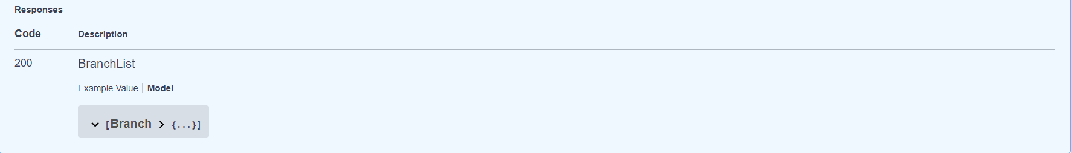

Name : S.Aswin

Roll no: 727722eucs501